**Shovon Roy**

[**www.linktr.ee/shhovon**](www.linktr.ee/shhovon)

**Introduction:**

*=>****Many of us who come from another district to study in Dhaka, live in a flat where we have to pay rent every month. Monthly rent consists of a few things such as room rent, meal cost, bazar, utilities expense and many more. Through this project one can calculate the monthly rent by giving user input for the above mentioned criterias, also from using values from file which are predefined.***

**Problem Analysis:**

***=>This project will solve the hassle of calculating rent each month which consumes a lot time. Bachelors can use this application and calculate the rent within a couple of minutes and save a lot of time.***

**UI Design Analysis:**

***=>In this application there are two input windows and one output window.***

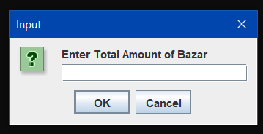

***GUI-1: This the first JOptionPane, which will take the user input for bazar.***

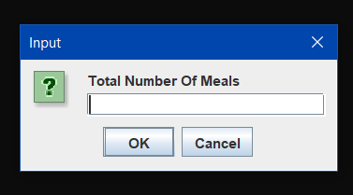

***GUI-2: This window will take input for the number of meals.***

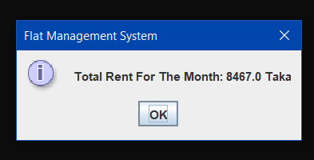

***GUI-3: This window will display the total rent for the month.***

**Logical Analysis:**

***=>There are a few logics used in this project such as gui, file, inheritance, encapsulation, polymorphism and some arithmetic operations. Two of the inputs are taken from user and the other two are directly accessed from file, thus the application displays the final output. All the logics used in the program are working properly although there are some logical limitations. User can not directly create a file in the code to put values and use it as inputs. There has to be a pre-created file present in the folder or package otherwise values can not be accessed.***

**OOP Concept Analysis:**

***=>OOP Principles used in this project:***

* ***Encapsulation: Scanner variables are private in file class.***
* ***Inheritance: I have used JOptionPane which is Java’s built-in class.***
* ***Polymorphism: There are two types of polymorphism in Java: compile-time polymorphism and runtime polymorphism. I have used Java built-in class JOptionPane in classes where method over-loading and method over-riding are held.***
* ***Inheritance: graphical user interface has been implemented using “JOptionPane”class also bodyclass inherits the fileclass.***

**Impact of this Project:**

***=> This project can have a great impact on the society if it is built more effectively. Through this project one can easily calculate the rent within a couple of minutes so if a software is built out of this concept, it can help both the flat owners and tenants calculate the rent more easily. It would reduce this hassle of calculating the amount on hand. People can be greatly benefitted from this project as it will save both their time and energy.***

**Limitations and Possible Future Improvements:**

***=>There are a few limitations to this project which can be improved and make a great application out of it.***

***Limitations- This project can only calculate rent for one person at a time. But there can be multiple persons living in the same flat. So there can be some improvements done which would allow the application to calculate rent for all the members of the flat.***

***Future improvements- I will update the application and add functions that will calculate rent for all the members of the flat at once.***